ISO 20022

Financial Instruments and Transactions Regulatory Reporting (Trade Repository Reporting) -  
Fast Track Maintenance 2022

Message Definition Report Part 1

Approved by the Securities SEG on 17 November 2022

This document provides information about the use of the messages for Financial Instruments and Transactions Regulatory Reporting and includes, for example, business transactions and examples.

December 2022

Table of contents

1. Introduction 5

1.1 Terms and definitions 5

1.2 Abbreviations and Acronyms 5

1.3 Document Scope and Objectives 6

1.4 References 6

2. Scope and Functionality 9

2.1 Background 9

2.2 Groups of MessageDefinitions and Functionality 10

3. BusinessRoles and Participants 13

4. BusinessProcess Description 15

4.1 BusinessProcess Diagram 15

4.2 Transaction reporting 16

4.3 Query message submission 17

4.4 Trade Repository response 17

4.5 Trade Repository submission of status advice message 17

5. Description of BusinessActivities 18

5.1 Query message submission 19

5.2 Trade Repository response 20

6. BusinessTransactions 21

6.1 Derivative reporting 21

6.2 Query message responded 22

6.3 Query message validation fail 23

7. Business Examples 24

7.1 Derivatives Trade Report Query - auth.029.001.03 24

7.2 Derivatives Trade Report - auth.030.001.03 25

7.3 Derivatives Trade State Report - auth.107.001.01 27

7.4 Derivatives Trade Margin Data Report - auth.108.001.01 29

7.5 Derivatives Trade Margin Data Transaction State Report - auth.109.001.01 30

7.6 Financial Instrument Reporting Status Advice - auth.031.001.01 31

7.7 Derivatives Trade Position Set Report – auth.090.001.01 32

7.8 Derivatives Trade Reconciliation Statistical Report – auth.091.001.02 35

7.9 Derivatives Trade Rejection Statistical Report – auth.092.001.03 36

7.10 Derivatives Trade Warnings Report – auth.106.001.01 37

8. Revision Record 39

Preliminary Note

The Message Definition Report (MDR) is made of three parts:

MDR Part 1

This describes the contextual background required to understand the functionality of the proposed message set. Part 1 is produced by the submitting organization that developed or maintained the message set in line with an MDR Part 1 template provided by the ISO 20022 Registration Authority (RA) on [www.iso20022.org](http://www.iso20022.org).

MDR Part 2

This is the detailed description of each message definition of the message set. Part 2 is produced by the RA using the model developed by the submitting organization.

MDR Part 3

This is an extract if the ISO 20022 Business Model describing the business concepts used in the message set. Part 2 is an Excel document produced by the RA.

# Introduction

## Terms and definitions

The following terms are reserved words defined in ISO 20022 – Part1. When used in this document, they will follow the UpperCamelCase notation.

| Term | Definition |
| --- | --- |
| BusinessRole | Functional role played by a business actor in a particular BusinessProcess or BusinessTransaction. |
| Participant | Involvement of a BusinessRole in a BusinessTransaction. |
| BusinessProcess | Definition of the business activities undertaken by BusinessRoles within a BusinessArea whereby each BusinessProcess fulfils one type of business activity and whereby a BusinessProcess may include and extend other BusinessProcesses. |
| BusinessTransaction | Particular solution that meets the communication requirements and the interaction requirements of a particular BusinessProcess and BusinessArea. |
| MessageDefinition | Formal description of the structure of a message instance. |

## Abbreviations and Acronyms

The following is a list of abbreviations and acronyms used in the document.

|  |  |
| --- | --- |
| Abbreviations/Acronyms | Definition |
| TR(s) | Trade Repository (ies) also known as Swap Data Repository (ies) or SDR(s) |
| CA(s) | Competent Authority (ies) |
| CA user | Any Competent Authority that will use the Access to Trade Repositories System to query and receive TRs’ data. |
| System User | Anyone who interacts with the Access to Trade Repositories System (a TR or a CA user). |
| Reporting Entity (RE) | Any entity that reports to a Trade repository under the scope of a regulation. It could be any of the following entities defined in such regulation: report submitting entity, reporting counterparty or entity responsible for reporting. |
| Access to Trade Repositories System / Central HUB | Access to Trade Repositories System is a single data query and data provision channel built by ESMA. |
| File | A physical file used to transmit messages between parties. It includes a message and the accompanying Business Application Header. |
| Message / report | A single instance of a message. |
| Record | A single data item describing an operation related to financial instruments, e.g. a derivative trade, an update or modification of a trade, a termination of a trade, etc. In the case of the Derivatives Trade Report message, many records representing different derivative trades can be included in a single message. |

## Document Scope and Objectives

This document is the first part of the ISO 20022 Message Definition Report (MDR) that describes the BusinessTransactions and underlying message set. For the sake of completeness, the document may also describe BusinessActivities that are not in the scope of the project.

This document sets:

* The BusinessProcess scope (business processes addressed or impacted by the project)
* The BusinessRoles involved in these BusinessProcesses

The main objectives of this document are:

* To explain what BusinessProcesses and BusinessActivities these MessageDefinitions have addressed
* To give a high level description of BusinessProcesses and the associated BusinessRoles
* To document the BusinessTransactions and their Participants (sequence diagrams)
* To list the MessageDefinitions

## References

| **Document** | **Version** | **Date** | **Author** |
| --- | --- | --- | --- |
| Commission Implementing Regulation (EU) 2017/104 of 19 October 2016 amending Delegated Regulation (EU) No 148/2013 supplementing Regulation (EU) No 648/2012 of the European Parliament and of the Council on OTC derivatives, central counterparties and trade repositories with regard to regulatory technical standards on the minimum details of the data to be reported to trade repositories | 1.0 | 19/10/2016 | European Commission |
| Commission Implementing Regulation (EU) 2017/105 of 19 October 2016 amending Implementing Regulation (EU) No 1247/2012 laying down implementing technical standards with regard to the format and frequency of trade reports to trade repositories according to Regulation (EU) No 648/2012 of the European Parliament and of the Council on OTC derivatives, central counterparties and trade repositories | 1.0 | 19/10/2016 | European Commission |
| Final report on draft technical standards on access to data and aggregation and comparison of data across TR under Article 81 of EMIR | 1.0 | 5/04/2016 | ESMA |
| Final report on guidelines for position calculation by Trade Repositories under EMIR | 1.0 | 27/03/2018 | ESMA |
| ISO20022BJ_Instruments_and_Transactions_ RegReporting_ESMA | 4.0 | 22/08/2018 | ESMA |
| [CDE Technical Guidance](https://www.bis.org/cpmi/publ/d175.htm) | 1.0 | 09/04/2018 | IOSCO GUUG |
| [Dodd-Frank Act – Part 43 & 45](https://comments.cftc.gov/FederalRegister/Final.aspx?) | 2.0 | 25/11/2020 | CFTC |
| EMIR REFIT (Regulation (EU) 2019/834 of the European Parliament and of the Council of 20 May 2019 amending Regulation (EU) No 648/2012 as regards the clearing obligation, the suspension of the clearing obligation, the reporting requirements, the risk-mitigation techniques for OTC derivative contracts not cleared by a central counterparty, the registration and supervision of trade repositories and the requirements for trade repositories) | 1.0 | 28/05/2019 | European Commission |
| COMMISSION DELEGATED REGULATION (EU) 2022/1855 of 10 June 2022 supplementing Regulation (EU) No 648/2012 of the European Parliament and of the Council with regard to regulatory technical standards specifying the minimum details of the data to be reported to trade repositories and the type of reports to be used | 1.0 | 07/10/2022 | European Commission |
| COMMISSION DELEGATED REGULATION (EU) 2022/1856 of 10 June 2022 amending the regulatory technical standards laid down in Delegated Regulation (EU) No 151/2013 by further specifying the procedure for accessing details of derivatives as well as the technical and operational arrangements for their access | 1.0 | 07/10/2022 | European Commission |
| COMMISSION DELEGATED REGULATION (EU) 2022/1858 of 10 June 2022 supplementing Regulation (EU) No 648/2012 of the European Parliament and of the Council with regard to regulatory technical standards specifying the procedures for the reconciliation of data between trade repositories and the procedures to be applied by the trade repository to verify the compliance by the reporting counterparty or submitting entity with the reporting requirements and to verify the completeness and correctness of the data reported | 1.0 | 07/10/2022 | European Commission |
| COMMISSION DELEGATED REGULATION (EU) 2022/1860 of 10 June 2022 laying down implementing technical standards for the application of Regulation (EU) No 648/2012 of the European Parliament and of the Council with regard to the standards, formats, frequency and methods and arrangements for reporting | 1.0 | 07/10/2022 | European Commission |
| Derivatives Trade Reporting messages (EMIR Refit) – Fast Track Maintenance (MCR #203 | 1.0 | 10 May 2022 | ESMA & CFTC |

# Scope and Functionality

## Background

This Message Definition Report covers a set of ten (10) ISO 20022 MessageDefinitions developed by the European Securities and Markets Authority (ESMA) in close collaboration with the Commodities Futures Trading Commission (CFTC), SWIFT and other authorities represented in the Regulatory Oversight Committee (ROC) Committee on Derivatives Identifiers and Data Elements (CDIDE) and approved by the Derivatives SubSEG in October 2022. These messages are specifically designed to support the reporting of derivative transactions data to the Trade Repositories in line with the CDE Technical Guidance issued by the IOSCO (and its specific implementation in the EU under the European Market Infrastructure Regulation [EMIR]), in the US under the Dodd-Frank Wall Street Reform and Consumer Protection Act as well as under other relevant regulations applicable in other jurisdictions.

The EMIR, specifically Art. 9, has introduced the obligation of reporting all derivatives contracts to Trade Repositories (TRs). TRs shall centrally store this information and make it available to relevant regulators (EMIR, art. 81).

Neither the Regulation nor the subsequent Technical Standards originally prescribed technical arrangements for Competent Authorities (CAs) and other regulators to access TRs’ data. This was left at the discretion of the TRs, and therefore each TR has so far adopted its own arrangements.

After the reporting go-live in 2014 authorities started accessing the trade data and encountered several major issues due to non-standard, sometimes insufficient tools and functionalities provided by TRs (e.g. the lack of a common format and channels for data access that would enable regulators to easily consolidate and process data received from various TRs).

Therefore, after thorough consideration of different options aiming to facilitate the access to TRs’ data ESMA has proposed to amend the relevant Technical Standards[1] so that TRs are required to develop facilities allowing queries and data provision to CAs in the ISO 20022 format[2].

ESMA has also decided to build a central access point allowing querying and receiving data from TRs (the Access to Trade Repositories System - TRACE). The messages are used by this system but can be also reused by other similar initiatives or in direct communication between CAs and TRs.

ESMA and the ROC have submitted a Message Change Request to adapt the auth.030.001.01 message to incorporate the CPMI-IOSCO Technical Guidance on the derivatives Critical Data Elements (CDE). This MCR was approved by the Securities SEG and Derivatives SubSEG on 30 November 2020.

Furthermore, ESMA and CFTC have submitted a Message Change Request in May 2022 to further align the message definitions with the final versions of the respective regulations and to enable adoption of the messages by the interested authorities. In particular, the auth.030.001.03 message has been adapted by accommodating for the relevant jurisdiction-specific data elements not covered by the CDE Technical Guidance. Additionally, other messages used in TRACE have been updated and new message definitions were developed in order to optimise the reporting of trade state and of margins as well as to enable provision of relevant reports by the TRs in line with EMIR REFIT requirements.

## Groups of MessageDefinitions and Functionality

The following types of messages are exchanged within the system:

* Data query messages that contain the definition of data request, i.e. the search criteria defined by the CAs. The centralized facility to create these messages will be provided by the Access to Trade Repositories System.
* Transaction data (both state and activity) messages that contain data provided by reporting firms to TRs as well as data provided by TRs to the CAs as responses to data query messages.
* Margin data (both state and activity) messages that contain data provided by reporting firms to TRs as well as data provided by TRs to the CAs as responses to data query messages.
* Position sets messages that contain data on aggregated exposures between a pair of counterparties, provided by TRs to the CAs as responses to data query messages.
* Reconciliation messages that contain cumulative information within the reference period for the reconciliation status of the reported and outstanding derivatives, provided by the TRs to the CAs as response to data query messages.
* Rejection messages that contain both aggregated and granular information on derivative submissions that were rejected, provided by TRs to the CAs as response to data query messages and provided by TRs to reporting firms in response to their original submission.
* Warning messages that contain both aggregated and granular information on derivative submissions that were warned, provided by TRs to the CAs as response to data query messages and provided by TRs to reporting firms in response to their original submission.
* Status advice (feedback) messages that contain technical information related to the status and potential errors in the communication process implemented between the involved parties.

*Note that these MessageDefinitions are to be used with the ISO 20022 Business Application Header (head.001). The schema and more information about the Business Application Header (BAH) can be found on the* [*www.iso20022.org*](http://www.iso20022.org/bah.page) *web site.*

|  |  |
| --- | --- |
| **MessageDefinition** | **Message Identifier** |
| Derivatives Trade Report Query | auth.029 |
| Derivatives Trade Report | auth.030 |
| Financial Instrument Reporting Status Advice | auth.031 |
| Derivatives Trade Position Set Report | auth.090 |
| Derivatives Trade Reconciliation Statistical Report | auth.091 |
| Derivatives Trade Rejection Statistical Report | auth.092 |
| Derivatives Trade Warnings Report | auth.106 |
| Derivatives Trade State Report | auth.107 |
| Derivatives Trade Margin Data Report | auth.108 |
| Derivatives Trade Margin Data Transaction State Report | auth.109 |

The **auth.030** message allows exchanging trade activity information, while **auth.107** message allows exchanging trade state information. Additional margin data is exchanged through separate messages **auth.108** (for activity information) and **auth.109** (for state information).

The regulation requires the trade counterparties to report all new derivative trades as well as all further modifications to the trades, including daily updates of the trade valuation. This represents the trade activity / life cycle. There might be many activity records related to a given trade, e.g. the trade execution (new trade), the trade modifications and valuations, the trade termination.

The structure of the **auth.030** message allows differentiating between different types of trade events that are reported. Transactions are individual trades between the counterparties and the regulation requires reporting every individual trade. As per the regulation, position level reporting can be used as a supplement to trade level reporting to report post-trade events, only if the individual trades in fungible products have been replaced by the position. This could be the case, for example, between a clearing member and a CCP. When the original trades are compressed, they should be reported respectively at the transaction level and the resulting net position can be reported at the position level.

For each derivative, the **auth.030** and **auth.107** messages differentiates between action types, including: New, Modification, Correction, Termination, Position Component, Valuation Update, Compression, Error, Port Out, Revive and Other.

The TRs are also expected to provide the trade state information in a separate **auth.107** message. It represents the state of the trade at a given point in time and that aggregates all the information (activity reports) submitted during the trade lifecycle, until the moment for which the trade state information is provide. E.g. if there was a ‘new’ record for a trade, then a ‘modification’ for one of the fields and three ‘valuation update’ records, the trade state would include all the information from the ‘new’ record, where the modified field contains the information from the ‘modification’ record (not from the ‘new’ record) and the value is taken from the most recent of the three ‘valuation’ records. There is always one trade state record for each trade for a given date, even if there are many trade activity records for this trade. In principle, the trade state record contains the same scope of information on a trade than the trade activity records.

The type of information to be provided in a report is specified in the data query message (**auth.029**). Specifically, the element TradLifeCyclHstry defines the type of information requested: ‘true’ – trade activity information (i.e. all lifecycle records on a given trade) or ‘false’ – current trade state (i.e. one aggregated record per trade). In addition, by using the OutsdngTradInd element one can specify if the TR should provide the above information only for outstanding trades (‘true’) i.e. trades that are not terminated yet; or all reported trades (‘false’), i.e. also already terminated trades.

The structure of the message for all action types and the trade state is the same and reflects the reporting requirements specified by the regulation. However, there are different requirements for different action types in terms of mandatory, optional and not applicable fields.[3] This may result in different usage guidelines and message restrictions to be applied in the components of each action type by the authorities.The **auth.090** message allows the Trade Repositories to report data to the relevant authorities on aggregated exposures between a pair of counterparties that comprise:

* Position sets;
* Collateral position sets;
* Currency positions sets; and
* Currency collateral position sets.

According to the Final report on guidelines for position calculation by Trade Repositories under EMIR[4], Position set report is considered as an aggregation of outstanding derivatives with similar dimensions, available to the CAs on a daily basis. Numerous positions sets will be produced according to the combination of dimensions used to stratify the derivatives, and different metrics will be used to represent the aggregations. Collateral positions sets relate to the position sets but instead present aggregations, using collateral fields as metrics, of collateral for derivative positions. Both reports should be provided to all authorities in line with their mandates.

Currency position sets are aggregations similar to those produced in position sets, however they are aggregated according to the currency of the position, for use by central banks issuing specific currencies. In terms of currency collateral position set, this report shows how currency positions are collateralised. It will provide aggregations of collateral with similar dimensions that relate to the currency position sets, with relevant collateral related metrics. Both reports should be provided to the relevant central banks of issue in line with their mandates.

The structure of the message for position set report and currency position set report is the same and reflects the reporting requirements specified by the guidelines. This results in the same version of components applied in the message. Similar approach is followed in case of collateral position set report and currency collateral position set report. However, there are different requirements for aggregations between the standard sets and their currency variants and the audience of those report may vary.

The **auth.091** message allows the Trade Repositories to report data to the relevant authorities with cumulative and granular information within the reference period for the reconciliation status of the reported and outstanding derivatives.

The **auth.092** message allows the Trade Repositories to report data to the relevant authorities with a count of all the rejections within the reference period for all reports and all trades submitted to the TRs and failed to pass data validations. In case of rejected transactions, indication of the reasons for rejection must be provided.

Similar approach is taken in the **auth.106** message which allows the Trade Repositories to report data to the relevant authorities with a count of all the warnings within the reference period for all trades submitted to the TRs and encountered warnings during data validations.

For the feedback to the above submitted data, as well as associated reference information, the existing message **auth.031** will be used. This message will provide a status advice for the correctness, issues or errors that arise from the submitted report. Please note that auth.031 is also part of the Financial Instruments and Transactions Regulatory Reporting (Transactions and Financial Instruments Data Reporting) message set.

# BusinessRoles and Participants

A BusinessRole represents an entity (or a class of entities) of the real world, physical or legal, a person, a group of persons, a corporation. Examples of BusinessRoles: “Financial Institution”, “ACH”, “CSD”.

A Participant is a functional role performed by a BusinessRole in a particular BusinessProcess or BusinessTransaction: for example the “user” of a system, “debtor”, “creditor”, “investor” etc.

The relationship between BusinessRoles and Participants is many-to-many. One BusinessRole (that is, a person) can be involved as different Participants at different moments in time or at the same time: "user", "debtor”, "creditor", "investor", etc. Different BusinessRoles can be involved as the same Participant.

In the context of derivatives transaction reporting and Access to Trade Repositories System, the high-level BusinessRoles and typical Participants can be represented as follows.

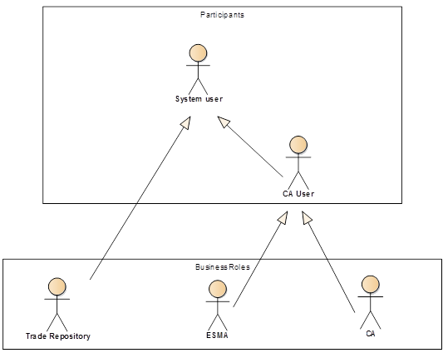

| **Participants and BusinessRoles definitions** | |
| --- | --- |
| **Description** | **Definition** |
| Participants | |
| CA user | A Competent Authority that will use The Access to Trade Repositories System and to query and receive TRs’ data. |
| System user | Anyone who interacts with the Access to Trade Repositories System (a TR or a CA user). |
| Central Hub | A data query and data provision channel. The Access to Trade Repositories System will serve the purpose of this channel in the case of ESMA. |
| Business Roles | |
| Authority | An authority that has access to derivatives transactions data at the Trade Repositories (TR) and will use it to query and receive TR data, |
| European Securities and Market Authority | European Securities and Markets Authority (ESMA) |
| Competent Authority (CA) | Competent Authority of each jurisdiction |
| Trade Repository (TR) | Legal person that centrally collects and maintains the records |
| Reporting Entity (RE) | Any entity that reports to a Trade repository under the scope of a regulation. |

|  |  |  |  |
| --- | --- | --- | --- |
| **BusinessRoles/Participants Matrix Table** | | |  |
| Participants  BusinessRoles | Reporting Entity | Trade Repository | Authority |
| Financial institution | x |  |  |
| Non-financial institution | x |  |  |
| CCP | x |  |  |
| CA |  |  | x |
| ESMA |  |  | x |
| TR |  | x |  |

# BusinessProcess Description

## BusinessProcess Diagram

This diagram pictures the high level BusinessProcesses covered by this project. The aim of the below is to describe the high-level scope of the project, not to be exhaustive.

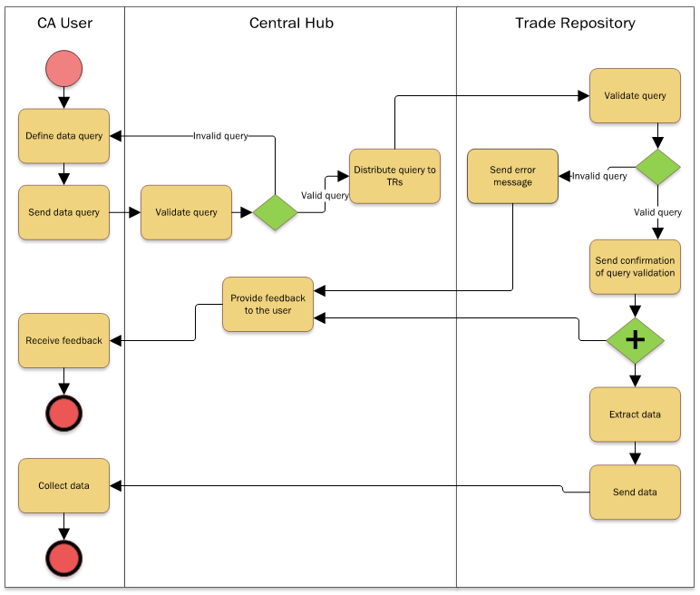

## Transaction reporting

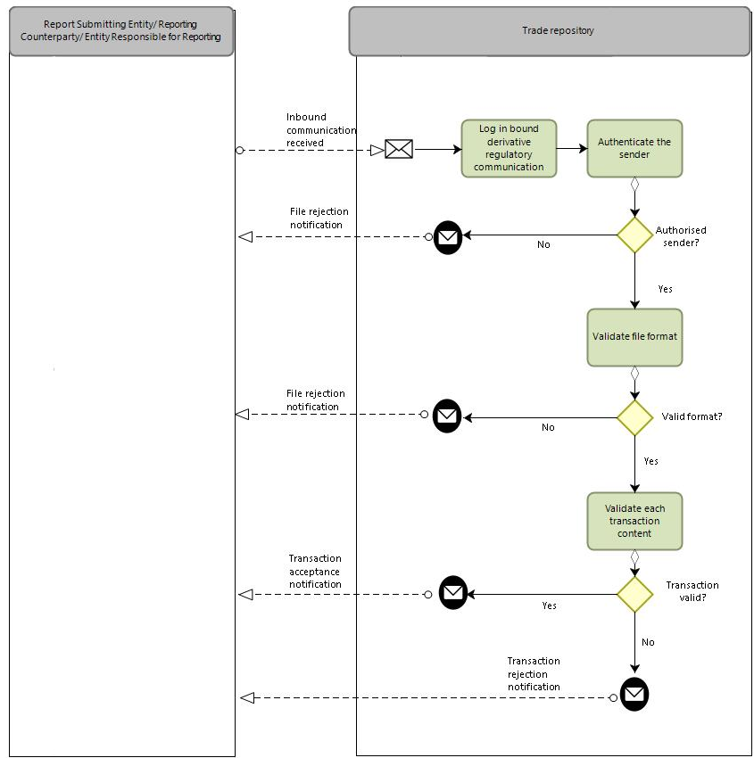

|  |  |  |
| --- | --- | --- |
| Step | Description | Initiator |
| Log inbound regulatory communication | TR receives data on a derivative transaction from the RE. | RE |
| Authenticate the sender | TR authenticates the sender of the derivative related data. If the sender is not authorized, the file will be rejected. | TR |
| Validate file format | TR checks the format of the file received. If the format is not correct, the file will be rejected. | TR |
| Validate each transaction content | TR confirms whether the content of the derivative related report matches the predefined schema. If the content is not correct, the file will be rejected. | TR |

## Query message submission

|  |  |
| --- | --- |
| **Item** | **Description** |
| Definition | The CA user defines a query (an ad-hoc query or a predefined recurrent) query and submits the query to Trade Repositories. |
| Trigger | CA user who wants to retrieve data from Trade Repositories. |
| Pre-conditions | The query must have been created. |
| Post-conditions | A query message is created and submitted to Trade Repositories. |
| Role | CA user |

## Trade Repository response

|  |  |
| --- | --- |
| **Item** | **Description** |
| Definition | Trade Repository responds to a query message with a transaction data response message and a feedback message. |
| Trigger | Trade Repository responds to a submitted query message. |
| Pre-conditions | Trade Repository has received and performed validation check to a query message. |
| Post-conditions | A feedback message and a transaction data message are created and sent to CA user. |
| Role | Trade Repository. |

## Trade Repository submission of status advice message

|  |  |
| --- | --- |
| **Item** | **Description** |
| Definition | Trade Repository sends a status advice message containing information about the status and potential errors of the received query message(s) from a CA user. This status advice message should either confirm or reject the received query message(s). |
| Trigger | Trade Repository has received a query message. |
| Pre-conditions | Trade Repository has received and performed a validation check to a query message. |
| Post-conditions | A status advice message is created and submitted to CA users. |
| Role | System user (Trade Repository). |

# Description of BusinessActivities

This section presents the different BusinessActivities within each BusinessProcess. BusinessActivities of a process are described in swim lane diagrams and are referred in this document as activity diagrams.

The development of an activity diagram is part of the ISO 20022 modelling process and allows capturing the requirements.

The activity diagram provides a zoom-in on the BusinessActivities taking place during each of the BusinessProcesses described in Section 0. It also shows the BusinessActivities that are triggered when another BusinessActivity has a negative result.

What is the activity diagram about?

* It is a diagram representing the ‘common lifecycle’ of a BusinessProcess
* A start point ⚫ shows where the lifecycle of the BusinessProcess commences and End pointthe end points show where the lifecycle may possibly end
* A lozenge means that a choice between several actions can be made
* A bar means that several actions are initiated in parallel
* The flow of activities between the involved Participants (parties)
* BusinessActivities may result in different actions, that is, information is conveyed from one party to another party.

Both in-scope and out-of-scope activities are included, with a different level of details. There are no information requirements for out-of-scope activities, except that they should be clearly identified in the diagram.

Activity diagrams are always accompanied with a text describing the BusinessActivities and their interactions.

## Query message submission

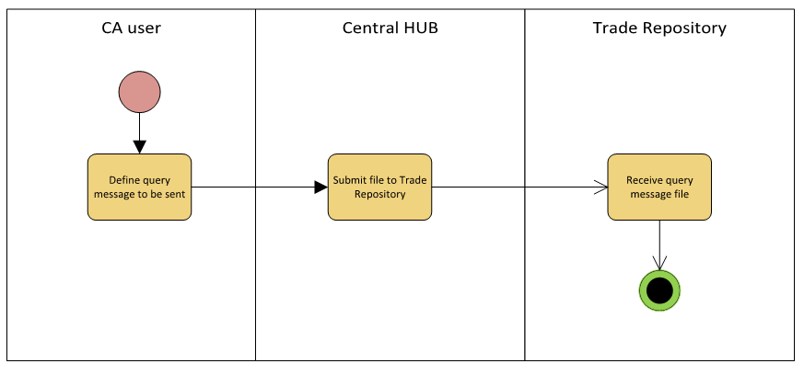

|  |  |  |
| --- | --- | --- |
| **Step** | **Description** | **Initiator** |
| Define query message to send | CA user creates the query message to be sent. | CA User |
| Submit file to Trade Repositories | Query message file is submitted to TRs. | Central HUB |
| Receive query message file | Trade Repository receives query message file. | Trade Repository |

## Trade Repository response

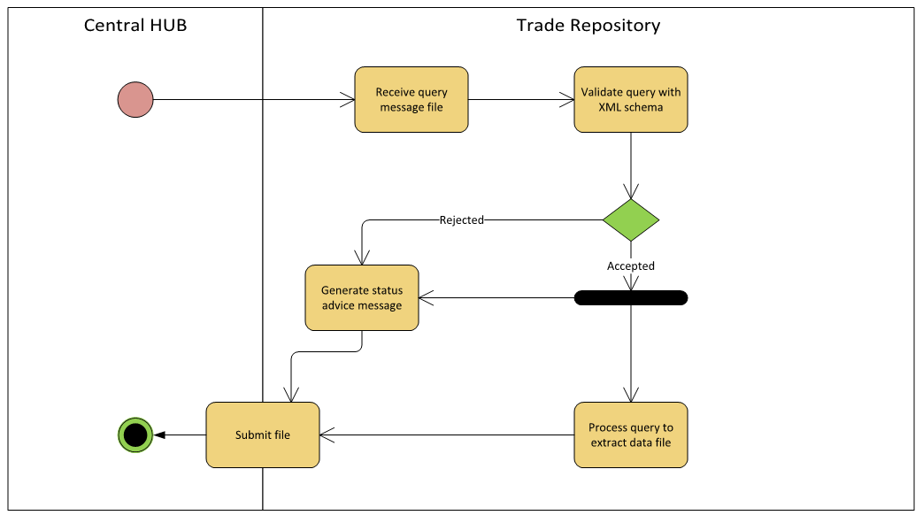

|  |  |  |
| --- | --- | --- |
| **Step** | **Description** | **Initiator** |
| Receive query message file | Trade Repository receives query message file from Central HUB system. | Trade Repository |
| Validate query with XML schema | Query message file is validated against XML schema. | Trade Repository |
| Generate status advice message | Trade Repository generates a status advice message, either to verify the validation of the query message or to inform about possible errors in case it is rejected. | Trade Repository |
| Process query to extract data file | Query message is processed and the transaction data file is produced. | Trade Repository |
| Submit file | Trade Repository submits the report file to the Central HUB / CA | Trade Repository |

# BusinessTransactions

This section describes the message flows based on the activity diagrams documented above. It shows the typical exchanges of information in the context of a BusinessTransaction. Three business scenarios are specifically presented:

## Derivative reporting

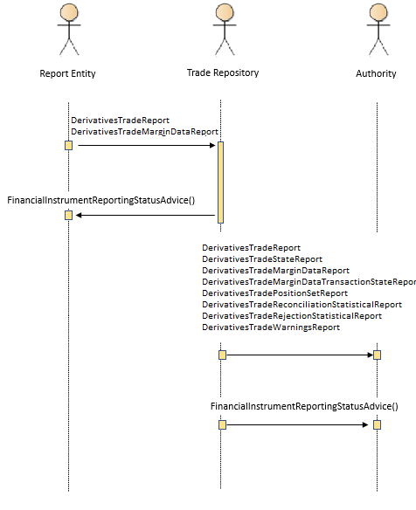

## Query message responded

Sequence 1

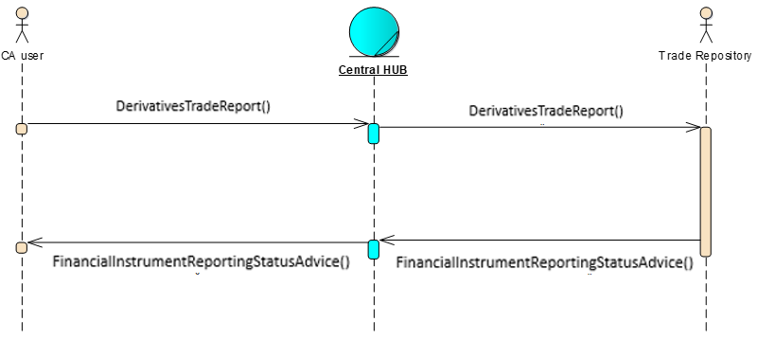

* CA user submits a query message to Trade Repository (Derivatives Trade Report Query).
* Trade Repository sends a status advice message to confirm query’s validation (Financial Instrument Reporting Status Advice).

Sequence 2

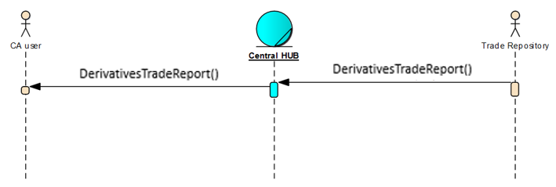

* Trade Repository sends a transaction data message as a response to query message (Derivatives Trade Report).

## Query message validation fail

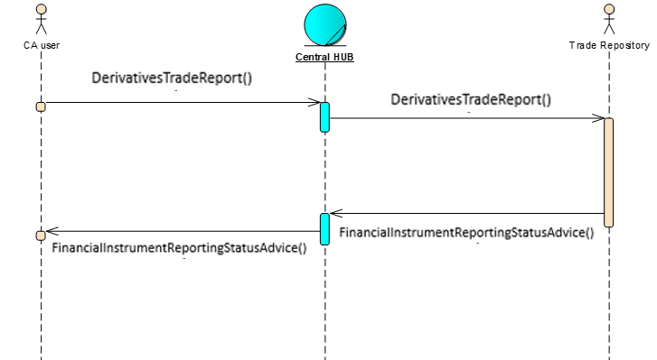

* CA user submits a query message to Trade Repository (DerivativesTrade Report Query).
* Trade Repository sends a status advice message to inform that query message failed the validation (Financial Instrument Reporting Status Advice).

# Business Examples

This section describes business examples of the use of the various MessageDefinitions. Each example starts with a description of the example scenario followed by the actual MessageInstance.

## Derivatives Trade Report Query - auth.029.001.03

**Description**

The following MessageInstance 1 provides an example of a query message. The CA user defines a query message to be sent to a Trade Repository, asking for any outstanding contract reported, as a new transaction in December 2015, with ISIN XS4589012033 either as a product or underlying instrument.

**MessageInstance 1**:

<DerivsTradRptQry>

<RqstngAuthrty>

<PrtryId>

<Id>CAAMF</Id>

</PrtryId>

</RqstngAuthrty>

<TradQryData>

<AdHocQry>

<TradLifeCyclHstry>false</TradLifeCyclHstry>

<OutsdngTradInd>true</OutsdngTradInd>

<FinInstrmCrit>

<Oprtr>ORRR</Oprtr>

<Id>

<ISIN>XS4589012033</ISIN>

</Id>

<UndrlygInstrmId>

<ISIN>XS4589012033</ISIN>

</UndrlygInstrmId>

</FinInstrmCrit>

<TmCrit>

<RptgDtTm>

<FrDtTm>2015-12-01T09:30:47Z</FrDtTm>

<ToDtTm>2015-12-31T09:30:47Z</ToDtTm>

</RptgDtTm>

</TmCrit>

<OthrCrit>

<ActnTp>NEWT</ActnTp>

</OthrCrit>

</AdHocQry>

</TradQryData>

</DerivsTradRptQry>

The following MessageInstance 2 provides an example of a query message. The CA user defines a query message to be sent to a Trade Repository, asking for all late trades recurrent query to be delivered on Tuesdays and Fridays.

**MessageInstance 2**:

<DerivsTradRptQry>

<RqstngAuthrty>

<PrtryId>

<Id>CAKNF</Id>

</PrtryId>

</RqstngAuthrty>

<TradQryData>

<RcrntQry>

<QryTp>ALTR</n1:QryTp>

<Frqcy>

<FrqcyTp>ADHO</FrqcyTp>

<DlvryDay>TUED</DlvryDay>

<DlvryDay>FRID</DlvryDay>

</Frqcy>

<VldUntil>1957-08-13</VldUntil>

</RcrntQry>

</TradQryData>

</DerivsTradRptQry>

## Derivatives Trade Report - auth.030.001.03

**Description**

The DerivativesTradeReport message is sent by the reporting entity to the trade repository (TR) to report on derivatives transactions or sent by the trade repository (TR) to the competent authority (CA) or made available by the trade repository (TR) to the report submitting entity and the reporting counterparty as well as the entity responsible for reporting, if applicable.

The message contains an option contract with ISIN XS4589012033 as the underlying instrument, reported on 17th December 2015.

**MessageInstance**:

<DerivsTradRpt>

<RptHdr>

<NbRcrds>1</NbRcrds>

</RptHdr>

<TradData>

<Rpt>

<New>

<CtrPtySpcfcData>

<CtrPty>

<RptgCtrPty>

<Id>

<Lgl>  
 <Id>

<LEI>520000HKCX80XG0KJ053</LEI>

<.Id>

</Lgl>

</Id>

<Ntr>

<FI>

<Sctr>

<Cd>INVF</Cd>

</Sctr>

</FI>

</Ntr>

<TradgCpcty>PRIN</TradgCpcty>

<DrctnOrSd>

<CtrPtySd>BYER</CtrPtySd>

</DrctnOrSd>

</RptgCtrPty>

<OthrCtrPty>

<IdTp>

<Lgl>

<LEI>743800WRLARIBCU2DU20</LEI>

</Lgl>

</IdTp>

<Ctry>DE</Ctry>

</OthrCtrPty>

<Bnfcry>

<Lgl>  
 <Id>

<LEI>743800WRLARIBCU2DU20</LEI>

<.Id>

</Lgl>

</Bnfcry>

</CtrPty>

<RptgTmStmp>2015-12-17T09:30:47Z</RptgTmStmp>

</CtrPtySpcfcData>

<CmonTradData>

<CtrctData>

<CtrctTp>OPTN</CtrctTp>

<AsstClss>INTR</AsstClss>

<PdctClssfctn>JESXCC</PdctClssfctn>

<UndrlygInstrm>

<ISIN>XS4589012033</ISIN>

</UndrlygInstrm>

<SttlmCcy><Ccy><EUR</Ccy></NtnlCcyFrstLeg>

</CtrctData>

<TxData>

<TxId>

<UnqTxIdr>AAAAABBBBBCCCCCDDD01ABC</UnqTxIdr>

</TxId>

<RptTrckgNb>6846468444</RptTrckgNb>

<PltfmIdr>XOFF</PltfmIdr>

<TxPric>

<Pric>

<MntryVal>

<Amt Ccy="EUR">10000</Amt>

</MntryVal>

</Pric>

</TxPric>

<NtnlAmt>

<FrstLeg><Amt><Amt>1000000</Amt></Amt></FrstLeg>

</NtnlAmt>

<Qty>

<Unit>100000</Unit>

</Qty>

<DlvryTp>OPTL</DlvryTp>

<ExctnDtTm>2015-12-16T14:30:47Z</ExctnDtTm>

<FctvDt>2015-12-16</FctvDt>

<TradConf>

<Confd>

<Tp>ECNF</Tp>

<TmStmp>2015-12-16T16:30:47Z</TmStmp>

</Confd>

</TradConf>

<TradClr>

<ClrOblgtn>FLSE</ClrOblgtn>

<ClrSts>

<NonClrd>NORE</NonClrd>

</ClrSts>

<IntraGrp>false</IntraGrp>

</TradClr>

<Optn>

<Tp>CALL</Tp>

<ExrcStyle>EURO</ExrcStyle>

<StrkPric>

<Pctg>101</Pctg>

</StrkPric>

</Optn>

</TxData>

</CmonTradData>

</New>

</Rpt>

</TradData>

</DerivsTradRpt>

## Derivatives Trade State Report - auth.107.001.01

**Description**

The DerivativesTradeStateReport message is sent by the reporting entity to the trade repository (TR) to report on derivatives transactions or sent by the trade repository (TR) to the competent authority (CA) or made available by the trade repository (TR) to the report submitting entity and the reporting counterparty as well as the entity responsible for reporting, if applicable.

The message contains a trade state of an option contract with ISIN XS4589012033 as the underlying instrument, reported on 17th December 2015.

**MessageInstance**:

<DerivsTradRpt>

<RptHdr>

<NbRcrds>1</NbRcrds>

</RptHdr>

<TradData>

<Stat>

<CtrPtySpcfcData>

<CtrPty>

<RptgCtrPty>

<Id>

<Lgl>  
 <Id>

<LEI>520000HKCX80XG0KJ053</LEI>

<.Id>

</Lgl>

</Id>

<Ntr>

<FI>

<Sctr>

<Cd>INVF</Cd>

</Sctr>

</FI>

</Ntr>

<TradgCpcty>PRIN</TradgCpcty>

<DrctnOrSd>

<CtrPtySd>BYER</CtrPtySd>

</DrctnOrSd>

</RptgCtrPty>

<OthrCtrPty>

<IdTp>

<Lgl>

<LEI>743800WRLARIBCU2DU20</LEI>

</Lgl>

</IdTp>

<Ctry>DE</Ctry>

</OthrCtrPty>

<Bnfcry>

<Lgl>  
 <Id>

<LEI>743800WRLARIBCU2DU20</LEI>

<.Id>

</Lgl>

</Bnfcry>

</CtrPty>

<RptgTmStmp>2015-12-17T09:30:47Z</RptgTmStmp>

</CtrPtySpcfcData>

<CmonTradData>

<CtrctData>

<CtrctTp>OPTN</CtrctTp>

<AsstClss>INTR</AsstClss>

<PdctClssfctn>JESXCC</PdctClssfctn>

<UndrlygInstrm>

<ISIN>XS4589012033</ISIN>

</UndrlygInstrm>

<SttlmCcy><Ccy><EUR</Ccy></NtnlCcyFrstLeg>

</CtrctData>

<TxData>

<TxId>

<UnqTxIdr>AAAAABBBBBCCCCCDDD01ABC</UnqTxIdr>

</TxId>

<RptTrckgNb>6846468444</RptTrckgNb>

<PltfmIdr>XOFF</PltfmIdr>

<TxPric>

<Pric>

<MntryVal>

<Amt Ccy="EUR">10000</Amt>

</MntryVal>

</Pric>

</TxPric>

<NtnlAmt>

<FrstLeg><Amt><Amt>1000000</Amt></Amt></FrstLeg>

</NtnlAmt>

<Qty>

<Unit>100000</Unit>

</Qty>

<DlvryTp>OPTL</DlvryTp>

<ExctnDtTm>2015-12-16T14:30:47Z</ExctnDtTm>

<FctvDt>2015-12-16</FctvDt>

<TradConf>

<Confd>

<Tp>ECNF</Tp>

<TmStmp>2015-12-16T16:30:47Z</TmStmp>

</Confd>

</TradConf>

<TradClr>

<ClrOblgtn>FLSE</ClrOblgtn>

<ClrSts>

<NonClrd>NORE</NonClrd>

</ClrSts>

<IntraGrp>false</IntraGrp>

</TradClr>

<Optn>

<Tp>CALL</Tp>

<ExrcStyle>EURO</ExrcStyle>

<StrkPric>

<Pctg>101</Pctg>

</StrkPric>

</Optn>

</TxData>

<CtrctMod>

<ActnTp>NEWT</ActnTp>

<Lvl>TCTN</Lvl>

</CtrctMod>

</CmonTradData>

</Stat>

</TradData>

</DerivsTradRpt>

## Derivatives Trade Margin Data Report - auth.108.001.01

**Description**

The DerivativesTradeMarginDataReport message is sent by the reporting entity to the trade repository (TR) to report on margins or sent by the trade repository (TR) to the competent authority (CA) or made available by the trade repository (TR) to the report submitting entity and the reporting counterparty as well as the entity responsible for reporting, if applicable.

The message contains a report of margin for a new derivative collateralized at portfolio level.

**MessageInstance**:

<MrgnUpd>  
 <RptgTmStmp>2023-07-19T18:05:45Z</RptgTmStmp>  
 <CtrPtyId>  
 <RptgCtrPty>  
 <Id><Lgl><Id><LEI>CCCCCCCCCCCCCCCCCCC</LEI></Id></Lgl></Id>  
 </RptgCtrPty>  
 <OthrCtrPty>  
 <IdTp><Lgl><Id><LEI>BBBBBBBBBB1111111111</LEI></Id></Lgl></IdTp>  
 </OthrCtrPty>  
 <SubmitgAgt>  
 <LEI>CCCCCCCCCCCCCCCCCCCC</LEI>  
 </SubmitgAgt>  
 <NttyRspnsblForRpt>  
 <LEI>CCCCCCCCCCCCCCCCCCCC</LEI>  
 </NttyRspnsblForRpt>  
 </CtrPtyId>  
 <EvtDt>2023-07-18</EvtDt>  
 <Coll>  
 <CollPrtflCd>  
 <Prtfl><Cd>CODEPORTFOLIO123</Cd></Prtfl>  
 </CollPrtflCd>  
 <CollstnCtgy>OWC1</CollstnCtgy>  
 <TmStmp>2023-07-18T18:00:00Z</TmStmp>

</Coll>  
 <PstdMrgnOrColl>  
 <InitlMrgnPstdPreHrcut Ccy="EUR">1000000</InitlMrgnPstdPreHrcut>  
 <InitlMrgnPstdPstHrcut Ccy="EUR">1000000</InitlMrgnPstdPstHrcut>  
 <VartnMrgnPstdPreHrcut Ccy="EUR">300000</VartnMrgnPstdPreHrcut>  
 <VartnMrgnPstdPstHrcut Ccy="EUR">300000</VartnMrgnPstdPstHrcut>  
 <XcssCollPstd Ccy="EUR">100000</XcssCollPstd>  
 </PstdMrgnOrColl>  
</MrgnUpd>

## Derivatives Trade Margin Data Transaction State Report - auth.109.001.01

**Description**

The DerivativesTradeMarginDataTransactionStateReport message is sent by the reporting entity to the trade repository (TR) to report on margins or sent by the trade repository (TR) to the competent authority (CA) or made available by the trade repository (TR) to the report submitting entity and the reporting counterparty as well as the entity responsible for reporting, if applicable.

The message contains a trade state report of margin for a derivative collateralized at portfolio level.

**MessageInstance**:

<Stat>  
 <RptgTmStmp>2023-07-19T18:05:45Z</RptgTmStmp>  
 <CtrPtyId>  
 <RptgCtrPty>  
 <Id><Lgl><Id><LEI>CCCCCCCCCCCCCCCCCCC</LEI></Id></Lgl></Id>  
 </RptgCtrPty>  
 <OthrCtrPty>  
 <IdTp><Lgl><Id><LEI>BBBBBBBBBB1111111111</LEI></Id></Lgl></IdTp>  
 </OthrCtrPty>  
 <SubmitgAgt>  
 <LEI>CCCCCCCCCCCCCCCCCCCC</LEI>  
 </SubmitgAgt>  
 <NttyRspnsblForRpt>  
 <LEI>CCCCCCCCCCCCCCCCCCCC</LEI>  
 </NttyRspnsblForRpt>  
 </CtrPtyId>  
 <EvtDt>2023-07-18</EvtDt>  
 <Coll>  
 <CollPrtflCd>  
 <Prtfl><Cd>CODEPORTFOLIO123</Cd></Prtfl>  
 </CollPrtflCd>  
 <CollstnCtgy>OWC1</CollstnCtgy>  
 <TmStmp>2023-07-18T18:00:00Z</TmStmp>

</Coll>  
 <PstdMrgnOrColl>  
 <InitlMrgnPstdPreHrcut Ccy="EUR">1000000</InitlMrgnPstdPreHrcut>  
 <InitlMrgnPstdPstHrcut Ccy="EUR">1000000</InitlMrgnPstdPstHrcut>  
 <VartnMrgnPstdPreHrcut Ccy="EUR">300000</VartnMrgnPstdPreHrcut>  
 <VartnMrgnPstdPstHrcut Ccy="EUR">300000</VartnMrgnPstdPstHrcut>  
 <XcssCollPstd Ccy="EUR">100000</XcssCollPstd>  
 </PstdMrgnOrColl>

<CtrctMod><ActnTp>MARU</ActnTp></CtrctMod>  
</Stat>

## Financial Instrument Reporting Status Advice - auth.031.001.01

**Description**

The following MessageInstance 1 provides an example of a status advice message from a Trade Repository, which confirms the validation of a received query message.

**MessageInstance 1:**

<FinInstrmRptgStsAdvc>

<StsAdvc>

<MsgSts>

<Sts>ACPT</Sts>

</MsgSts>

</StsAdvc>

</FinInstrmRptgStsAdvc>

The following MessageInstance 2 provides an example of a status advice message from a System to Trade Repository with a reminder that the response to query is missing.

**MessageInstance 2:**

<FinInstrmRptgStsAdvc>

<StsAdvc>

<MsgSts>

<Sts>RMDR</Sts>

<VldtnRule>

<Id>FIL-020</Id>

<Desc>Response to query is missing.</Desc>

</VldtnRule>

<MsgDt>2020-10-21Z</MsgDt>

</MsgSts>

</StsAdvc>

</FinInstrmRptgStsAdvc>

## Derivatives Trade Position Set Report – auth.090.001.01

**Description**

The following MessageInstance provides an example of a position set report response to the previously submitted query. The message contains a position set and a collateral position set aggregated by derivatives which have corresponding entries for each of the fields which the guidelines define as dimensions, calculated on 20th October 2020.

**MessageInstance**:

<DerivsTradPosSetRpt>

<AggtdPos>

<Rpt>

<RefDt>2020-10-20</RefDt>

<PosSet>

<Dmnsns>

<CtrPtyId>

<RptgCtrPty>

<Id>

<LEI>00000000000000000000</LEI>

</Id>

</RptgCtrPty>

<OthrCtrPty>

<Id>

<LEI>00000000000000000000</LEI>

</Id>

</OthrCtrPty>

</CtrPtyId>

<ValCcy>EUR</ValCcy>

<Collstn>PRCL</Collstn>

<Prtfl>651H</Prtfl>

<CtrctTp>SWAP</CtrctTp>

<AsstClss>COMM</AsstClss>

<UndrlygInstrm>

<ISIN>FR0000000000</ISIN>

</UndrlygInstrm>

<FrstLegNtnlCcy>EUR</FrstLegNtnlCcy>

<DlvrblCcy>EUR</DlvrblCcy>

<MstrAgrmt>

<Tp>XXXX</Tp>

<Vrsn>2009</Vrsn>

</MstrAgrmt>

<ClrSts>true</ClrSts>

<IntraGrp>false</IntraGrp>

<TmToMtrty>

<Prd>

<Start>

<Unit>YEAR</Unit>

<Val>2</Val>

</Start>

<End>

<Unit>YEAR</Unit>

<Val>3</Val>

</End>

</Prd>

</TmToMtrty>

<Cmmdty>EMAL</Cmmdty>

</Dmnsns>

<Mtrcs>

<Ttl>

<Buyr>

<NbOfTrds>1</NbOfTrds>

<Postv>

<Ntnl Ccy="EUR">2704000</Ntnl>

<Val Ccy="EUR">0</Val>

</Postv>

<Neg>

<Ntnl Ccy="EUR">0</Ntnl>

<Val Ccy="EUR">72194.1</Val>

</Neg>

</Buyr>

<Sellr>

<NbOfTrds>1</NbOfTrds>

<Postv>

<Ntnl Ccy="EUR">4000000</Ntnl>

<Val Ccy="EUR">115496</Val>

</Postv>

<Neg>

<Ntnl Ccy="EUR">0</Ntnl>

<Val Ccy="EUR">0</Val>

</Neg>

</Sellr>

</Ttl>

<Clean>

<Buyr>

<NbOfTrds>1</NbOfTrds>

<Postv>

<Ntnl Ccy="EUR">2704000</Ntnl>

<Val Ccy="EUR">0</Val>

</Postv>

<Neg>

<Ntnl Ccy="EUR">0</Ntnl>

<Val Ccy="EUR">72194.1</Val>

</Neg>

</Buyr>

<Sellr>

<NbOfTrds>1</NbOfTrds>

<Postv>

<Ntnl Ccy="EUR">4000000</Ntnl>

<Val Ccy="EUR">115496</Val>

</Postv>

<Neg>

<Ntnl Ccy="EUR">0</Ntnl>

<Val Ccy="EUR">0</Val>

</Neg>

</Sellr>

</Clean>

</Mtrcs>

</PosSet>

<CollPosSet>

<Dmnsns>

<CtrPtyId>

<RptgCtrPty>

<Id>

<LEI>00000000000000000000</LEI>

</Id>

</RptgCtrPty>

<OthrCtrPty>

<Id>

<LEI>00000000000000000000</LEI>

</Id>

</OthrCtrPty>

</CtrPtyId>

<Collstn>FLCL</Collstn>

<InitlMrgnPstdCcy>EUR</InitlMrgnPstdCcy>

<VartnMrgnPstdCcy>EUR</VartnMrgnPstdCcy>

<InitlMrgnRcvdCcy>EUR</InitlMrgnRcvdCcy>

<VartnMrgnRcvdCcy>EUR</VartnMrgnRcvdCcy>

<XcssCollPstdCcy>EUR</XcssCollPstdCcy>

<XcssCollRcvdCcy>EUR</XcssCollRcvdCcy>

</Dmnsns>

<Mtrcs>

<Ttl>

<NbOfRpts>1</NbOfRpts>

<InitlMrgn>

<Pstd Ccy="EUR">3.0000000000000000012</Pstd>

<Rcvd Ccy="EUR">50.000000000000000123</Rcvd>

</InitlMrgn>

<VartnMrgn>

<Pstd Ccy="EUR">40.000000000000123212</Pstd>

<Rcvd Ccy="EUR">60.000000000000004569</Rcvd>

</VartnMrgn>

<XcssCsh>

<Pstd Ccy="EUR">10.023652365236523652</Pstd>

<Rcvd Ccy="EUR">5</Rcvd>

</XcssCsh>

</Ttl>

<Clean>

<NbOfRpts>1</NbOfRpts>

<InitlMrgn>

<Pstd Ccy="EUR">3.0000000000000000012</Pstd>

<Rcvd Ccy="EUR">50.000000000000000123</Rcvd>

</InitlMrgn>

<VartnMrgn>

<Pstd Ccy="EUR">40.000000000000123212</Pstd>

<Rcvd Ccy="EUR">60.000000000000004569</Rcvd>

</VartnMrgn>

<XcssCsh>

<Pstd Ccy="EUR">10.023652365236523652</Pstd>

<Rcvd Ccy="EUR">5</Rcvd>

</XcssCsh>

</Clean>

</Mtrcs>

</CollPosSet>

</Rpt>

</AggtdPos>  
</DerivsTradPosSetRpt>

## Derivatives Trade Reconciliation Statistical Report – auth.091.001.02

**Description**

The following MessageInstance provides an example of a reconciliation report response to the previously submitted query. The message contains a cumulative information for the reconciliation status of the reported and outstanding derivatives.

**MessageInstance**:

<Rpt>

…

<RcncltnCtgrs>

<RptgRqrmnt>

<RptgTp>TWOS</RptgTp>

<Pairg>PARD</Pairg>

<Rcncltn>RECO</Rcncltn>

<ValtnRcncltn>RECO</ValtnRcncltn>

<Rvvd>true</Rvvd>

<FrthrMod>true</FrthrMod>

</RptgRqrmnt>

</RcncltnCtgrs>

<TtlNbOfTxs>10</TtlNbOfTxs>

<TxDtls>

<CtrPtyId>

<RptgCtrPrty>

<LEI>12345678901234500000</LEI>

</RptgCtrPrty>

…

</CtrPtyId>

<TtlNbOfTxs>10</TtlNbOfTxs>

<RcncltnRpt>

<TxId>

<OthrCtrPty>

<Lgl><LEI>ABCDEFGHIJKLMNOPQRST</LEI></Lgl>

</OthrCtrPty>

<UnqIdr>

<UnqTxIdr>UTI1</UnqTxIdr>

</UnqIdr>

</TxId>

<MtchgCrit>

…

</MtchgCrit>

</RcncltnRpt>

</TxDtls>

</Rpt>

## Derivatives Trade Rejection Statistical Report – auth.092.001.03

**Description**

The following MessageInstance provides an example of a rejection statistical report response to the previously submitted query. The message contains information on report submissions and derivative submissions, in particular on a single rejection of derivative that failed to pass business validations identified as ‘EMIR-VR-1001-6’.

**MessageInstance:**

…

<RjctnSttstcs>

<CtrPtyId>

<RptgCtrPrty>

<LEI>12345678901234500000</LEI>

</RptgCtrPrty>

<RptSubmitgNtty>

<LEI>12345678901234500000</LEI>

</RptSubmitgNtty>

<NttyRspnsblForRpt>

<LEI>12345678901234500000</LEI>

</NttyRspnsblForRpt>

</CtrPtyId>

<RptSttstcs>

<TtlNbOfRpts>1</TtlNbOfRpts>

<TtlNbOfRptsAccptd>1</TtlNbOfRptsAccptd>

<TtlNbOfRptsRjctd>0</TtlNbOfRptsRjctd>

</RptSttstcs>

<DerivSttstcs>

<DtldSttstcs>

<TtlNbOfTxs>10</TtlNbOfTxs>

<TtlNbOfTxsAccptd>9</TtlNbOfTxsAccptd>

<TtlNbOfTxsRjctd>1</TtlNbOfTxsRjctd>

<TxsRjctnsRsn>

<TxId>

<ActnTp>NEWT</ActnTp>

<RptgTmStmp>2025-0407T10:00:00Z</RptgTmStmp>

<DerivEvtTp>TRAD</DerivEvtTp>

<EvtTmStmp><Dt>2025-04-07</Dt></EvtTmStmp>

<OthrCtrPty>

<Lgl><LEI>ABCDEFGHIJKLMNOPQRST</LEI></Lgl>

</OthrCtrPty>

<UnqIdr><UnqTxIdr>UTI1</UnqTxIdr></UnqIdr>

</TxId>

<Sts>RJCT</Sts>

<DtldVldtnRule><Id>EMIR-VR-1001-6</Id></DtldVldtnRule>

</TxsRjctnsRsn>

</DtldSttstcs>

…

## Derivatives Trade Warnings Report – auth.106.001.01

**Description**

The following MessageInstance 1 provides an example of a warnings report message from a Trade Repository to the requesting authority, specifically focusing on missing valuations.

**MessageInstance 1:**

<MssngValtn>

<Rpt>

<NbOfOutsdngDerivs>10</NbOfOutsdngDerivs>

<NbOfOutsdngDerivsWithNoValtn>1</NbOfOutsdngDerivsWithNoValtn>

<NbOfOutsdngDerivsWithOutdtValtn>0</NbOfOutsdngDerivsWithOutdtValtn>

<Wrnngs>

<CtrPtyId>

<RptgCtrPrty>

<LEI>12345678901234500000</LEI>

</RptgCtrPrty>

<RptSubmitgNtty>

<LEI>12345678901234500000</LEI>

</RptSubmitgNtty>

<NttyRspnsblForRpt>

<LEI>12345678901234500000</LEI>

</NttyRspnsblForRpt>

</CtrPtyId>

<NbOfOutsdngDerivs>10</NbOfOutsdngDerivs>

<NbOfOutsdngDerivsWithNoValtn>1</NbOfOutsdngDerivsWithNoValtn>

<NbOfOutsdngDerivsWithOutdtValtn>0</NbOfOutsdngDerivsWithOutdtValtn>

<TxDtls>

<TxId>

<OthrCtrPty>

<Lgl><LEI>ABCDEFGHIJKLMNOPQRST</LEI></Lgl>

</OthrCtrPty>

<UnqIdr>

<UnqTxIdr>UTI1</UnqTxIdr>

</UnqIdr>

</TxId>

<ValtnAmt><Amt Ccy="EUR">5000000</Amt></ValtnAmt>

<ValtnTmStmp>2023-04-07T10:00:00Z</ValtnTmStmp>

</TxDtls>

</Wrnngs>

</MssngValtn>

**Description**

The following MessageInstance 2 provides an example of a warnings report message from a Trade Repository to the requesting authority, specifically focusing on missing margin information.

**MessageInstance 2:**

<MssngMrgnInf>

<Rpt>

<NbOfOutsdngDerivs>10</NbOfOutsdngDerivs>

<NbOfOutsdngDerivsWithNoMrgnInf>1</NbOfOutsdngDerivsWithNoMrgnInf>

<NbOfOutsdngDerivsWithOutdtMrgnInf>0</NbOfOutsdngDerivsWithOutdtMrgnInf>

<Wrnngs>

<CtrPtyId>

<RptgCtrPrty>

<LEI>12345678901234500000</LEI>

</RptgCtrPrty>

<RptSubmitgNtty>

<LEI>12345678901234500000</LEI>

</RptSubmitgNtty>

<NttyRspnsblForRpt>

<LEI>12345678901234500000</LEI>

</NttyRspnsblForRpt>

</CtrPtyId>

<NbOfOutsdngDerivs>10</NbOfOutsdngDerivs>

<NbOfOutsdngDerivsWithNoMrgnInf>1</NbOfOutsdngDerivsWithNoMrgnInf>

<NbOfOutsdngDerivsWithOutdtMrgnInf>0</NbOfOutsdngDerivsWithOutdtMrgnInf>

<TxDtls>

<TxId>

<OthrCtrPty>

<Lgl><LEI>ABCDEFGHIJKLMNOPQRST</LEI></Lgl>

</OthrCtrPty>

<UnqIdr>

<UnqTxIdr>UTI1</UnqTxIdr>

</UnqIdr>

</TxId>

<CollTmStmp>2023-04-07T10:00:00Z</CollTmStmp>

</TxDtls>

</Wrnngs>

</MssngMrgnInf>

**Description**

The following MessageInstance 3 provides an example of a warnings report message from a Trade Repository to the requesting authority, specifically focusing on abnormal values.

**MessageInstance 3:**

<AbnrmlVals>

<Rpt>

<NbOfDerivsRptd>10</NbOfDerivsRptd>

<NbOfDerivsRptdWthOtlrs>1</NbOfDerivsRptdWthOtlrs>

<Wrnngs>

<CtrPtyId>

<RptgCtrPrty>

<LEI>12345678901234500000</LEI>

</RptgCtrPrty>

<RptSubmitgNtty>

<LEI>12345678901234500000</LEI>

</RptSubmitgNtty>

<NttyRspnsblForRpt>

<LEI>12345678901234500000</LEI>

</NttyRspnsblForRpt>

</CtrPtyId>

<NbOfDerivsRptd>10</NbOfDerivsRptd>

<NbOfDerivsRptdWthOtlrs>1</NbOfDerivsRptdWthOtlrs>

<TxDtls>

<TxId>

<OthrCtrPty>

<Lgl><LEI>ABCDEFGHIJKLMNOPQRST</LEI></Lgl>

</OthrCtrPty>

<UnqIdr>

<UnqTxIdr>UTI1</UnqTxIdr>

</UnqIdr>

</TxId>

<NtnlAmt>

<FrstLeg>

<Amt><Amt Ccy="EUR">10000</Amt></Amt>

<SchdlPrd>

<Amt><Amt Ccy="EUR">10000</Amt></Amt>

</SchdlPrd>

</FrstLeg>

<ScndLeg>

<Amt><Amt Ccy="GBP">3000</Amt></Amt>

<SchdlPrd>

<Amt><Amt Ccy="EUR">3000</Amt></Amt>

</SchdlPrd>

</ScndLeg>

</NtnlAmt>

</TxDtls>

</Wrnngs>

</AbnrmlVals>

# Revision Record

|  |  |  |  |  |
| --- | --- | --- | --- | --- |
| **Revision** | **Date** | **Author** | **Description** | **Sections affected** |
| 0.1 | 13 April 2016 | ESMA | First version for submission to RA | All |
| 1.0 | 14 April 2016 | ISO 20022 RA | Editing for SEG submission | All |
| 1.1 | 1 February 2017 | ESMA | Revision following the Derivatives SubSEG comments | 2,7 |
| 1.2 | 15 April 2019 | ESMA | Updates to messages and new messages for reconciliation, rejection and position reporting | All |
| 2.0 | 10 March 2020 | ISO 20022 RA | Approved version | Cover page |
| 3.0 | 30 November 2020 | ESMA/ROC | Updates to auth.030 message | All |
| 4.0 | 20 December 2022 | ESMA | Updates to all messages (except of auth.031 and auth.090) in scope of the message set | All |

**Disclaimer**:

Although the Registration Authority has used all reasonable efforts to ensure accuracy of the contents of the iso20022.org website and the information published thereon, the Registration Authority assumes no liability whatsoever for any inadvertent errors or omissions that may appear thereon. Moreover, the information is provided on an "as is" basis. The Registration Authority disclaims all warranties and conditions, either express or implied, including but not limited to implied warranties of merchantability, title, non-infringement and fitness for a particular purpose.

The Registration Authority shall not be liable for any direct, indirect, special or consequential damages arising out of the use of the information published on the iso20022.org website, even if the Registration Authority has been advised of the possibility of such damages.

**Intellectual Property Rights**:

The ISO 20022 MessageDefinitions described in this document were contributed by ESMA. The ISO 20022 IPR policy is available at www.ISO20022.org > About ISO 20022 > Intellectual Property Rights.

1. https://www.esma.europa.eu/sites/default/files/library/2016-422_final_report_rts_on_tr_data_under_art.81_emir.pdf
2. The requirement to use ISO 20022 did not however apply to the reporting between trade counterparties and Trade Repositories
3. The business validation rules have been defined in a specific policy documentation published by ESMA, i.e. <https://www.esma.europa.eu/sites/default/files/library/esma74-362-853_emir_validation_rules_for_revised_rts_its.xlsx> for the present version of the EMIR technical standards. A similar documentation has been also developed for the new version of the EMIR technical standards that will apply as of April 2024: <https://www.esma.europa.eu/sites/default/files/library/esma74-362-2683_emir_refit_validation_rules_reconciliation_tolerances_and_template_for_notifications_of_dq_issues.xlsx> .
4. <https://www.esma.europa.eu/sites/default/files/library/esma70-151-1272_guidelines_on_position_calculation_by_trade_repositories_under_emir_final_report.pdf>